Name: Teacher:

Date: **ANSWER SHEET**

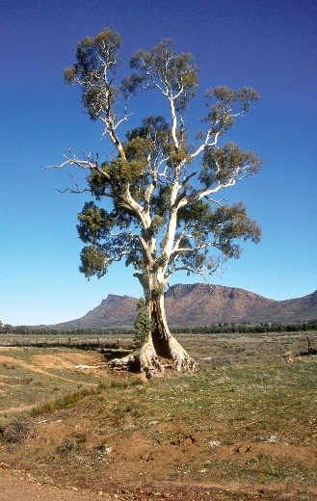 **YEAR 8 ENGLISH TEST 1**

**ETYOMOLOGY**

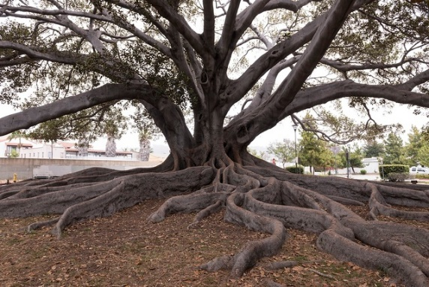

English is ALIVE! It is a LIVING language, and it is growing all the time!

One way that new words come into being a part of language is when words are **borrowed from other languages. New words** are also **created** when **words** or **word elements** such as **roots**, **prefixes** and **suffixes** are combined in new ways.

Section 1

1. **Write definitions / meaning for the following words. Write the answer in the spaces provided. Give at least 2 examples for each question.**
2. **Etymology**: the study of the origin of words and the way in which their meanings have changed throughout history.
3. **Prefix**: a word, letter, or number placed before another.
4. **Suffix**: are a letter or group of letters added to the ending of words to change their **meaning** or function
5. **Root Word:** A **root word** is a **word** or **word** part that can form the basis of new **words** through the addition of prefixes and suffixes. Understanding the meanings of common **roots** can help you work out the meanings of new **words** as you encounter them. ... Once you pull off any prefixes or suffixes, the **root** is usually **what** remains
6. **Language**: the words, their pronunciation, and the methods of combining them used and understood by a community studied the French *language*
7. **Phonics:** is the study of sound or a method of teaching reading. An **example** of **phonics** is a method used to teach reading by learning the sounds that groups of letters make when spoken.
8. **Alphabet**: a set of letters or symbols in a fixed order used to represent the basic set of speech sounds of a language, especially the set of letters from A to Z. Example - "the first letter of the alphabet"
9. **Dictionary**: The **definition** of a **dictionary** is an online or printed resource that lists words in alphabetical order, listing the **meaning**, pronunciation and part of speech for the word. An **example** of **dictionary** is YourDictionary.com. An **example** of **dictionary** is Webster's New World College **Dictionary**.

**Worth 8 Marks**

**/ 8**

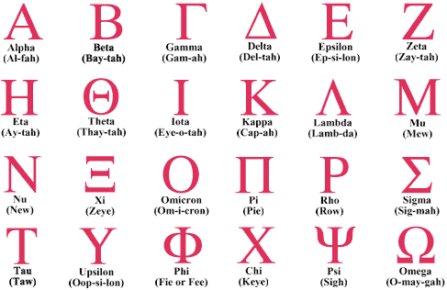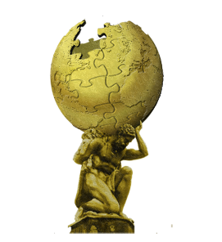

Section 2

Match the WORD with its MEANING

A series of words have been listed in the table below. In the table, match

the words with their language of origin and meaning.

|  |  |  |
| --- | --- | --- |
| **Word** | **Language of Origin** | **Meaning** |
| Adder | Old English ‘naedre’ | snake |
| Atlas | Greek | Carrying the world on his shoulders |
| Genie | Genius | Guardian spirit |
| Sal | Latin | Salt. People were paid by this currency |
| Hamburger | German | Meaning meat form Hamburg/Germany |
| Butler | Old French – ‘bouteillier’ | Bottle bearer |
| Monster | Latin - ‘monere’ | A large frightening creature – often imaginary |
| Crater | Krater | Mixing bowl |

**Worth 4 marks (1/2 mark per answer) / 4**



**Section 3** Multiple Choice - Etymology Quiz

Select the best definition/answer for each question. Circle either A, B, C, D or E to record your answer.

1. Which is NOT a reason for linguistic divergence?
2. Migration and encountering different groups and environments
3. Political and historical events
4. Different brain structure among different groups of people
5. What is a proto-language?
6. A very primitive language
7. The earliest known ancestor of a group of related languages
8. A basic form of a language as spoken by people learning it
9. What does it mean for two languages to be related?
10. They are spoken in the same country or region
11. They are written in the same alphabet
12. They evolved from the same older language
13. Which of these words are most likely to be borrowed from another language?
14. Words from family members
15. Pronouns
16. Words for plants and animals
17. The Latin word ‘Prunus' means:
18. Plum
19. Prune
20. Potato
21. Thursday comes from the Viking word Thorsdagr, meaning the day of:
22. Fur
23. Thor
24. First
25. Funny
26. Which is a modern-day country that Vikings originated from?
27. Scandinavia
28. Denmark
29. Sweden
30. Norway
31. All the above
32. Etymology is the study of?
33. Origin words
34. World culture
35. Latin root words
36. How word meanings have changed throughout time and history
37. Both A and D
38. The word ‘**October’** is derived from:
39. Latin
40. Greek
41. German
42. Dutch
43. The word ‘**Plant’** is derived from?
44. Greek
45. Dutch
46. Latin
47. German
48. Choose which words have **prefixes** from the following options. Read carefully.
49. uncover, mistaken, review, unfold
50. reviewed, walking, reversible, safely
51. antibiotic, forecast, monobrow, anti-gravity - ?
52. mistaken, reversible, unsafe, review
53. Choose which answer have **suffixes** from the following options. Read carefully.
54. discover, happiness, fulfilled, walked
55. running, happiness, joyful, colourful
56. colourful, unhappy, impossible, carefully
57. careless, happiness, colourful, running

**Marks out of 12 / 12 marks**

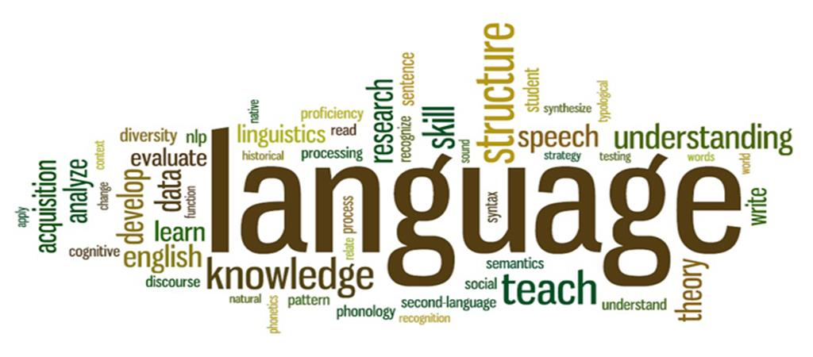

Section 4

**SUFFIXES**: Make adjectives by using the suffixes : -OUS , -AL , -Y , -IVE , -ABLE , -FUL , -LESS

dangerous

1. danger –

creative

1. create –

dirty

1. dirt -

drinkable

1. drink –

careless

careful

1. care - or or careless

musical

1. music –

famous

1. fame -

political

1. politic –

useless

useful

1. use - or

sunny

1. sun –

industrious

1. industry-

wonderful

1. wonder -

enjoyable

1. enjoy –

thoughtless

1. thought - or

thoughtful

1. attract –

attractive

1. Comfort -

comfortable

1. wash –

washable

1. home –

homeless

1. economic –

economical

**Marks out of 22 / 22**

**Section 5 – Short written answer**

The history of the English language really started with the arrival of three Germanic tribes who invaded Britain during the 5th century AD. These tribes, the Angles, the Saxons and the Jutes, crossed the North Sea from what today is Denmark and northern Germany. At that time the inhabitants of Britain spoke a Celtic language. But most of the Celtic speakers were pushed west and north by the invaders - mainly into what is now Wales, Scotland and Ireland. The Angles came from **England** and their language was called **Englisc** - from which the words England and English are derived.

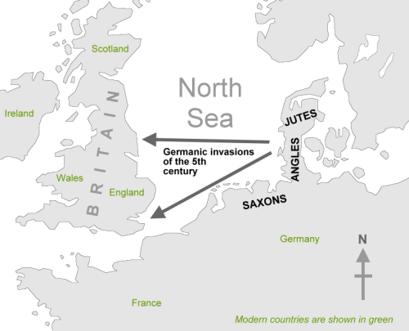

**In your own words, describe the first stage of the development of English:**

The history of the English language started with the arrival of three Germanic tribes who invaded Britain during the 5th century AD. These tribes, the Angles, the Saxons and the Jutes, crossed the North Sea from what today is Denmark and northern Germany

The Angles came from **England** and their language was called **Englisc** - from which the words England and English are derived.

**Marks out of / 4**

**Whole Test Marks / 50**

